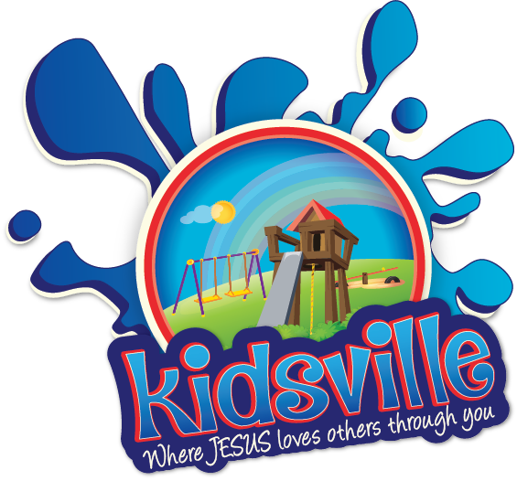
Kidsville Registration Form
North Cascade Seventh-day Adventist Church
800 Peacock Lane, Burlington 360-757-7577

June 27 – July 1
9:00 am – 12:15pm

Name: ___________________________________________ (One form per child please)

Grade Completed: __________ Birthday: _______/_____/_______ Age: _____________

Parent’s Name(s): ________________________________________________________

Home Address: __________________________________________________________

Home Phone: (_______)_____________ Alternate Phone: (_______)________________

Emergency Contact: _______________________ Relationship to Student:____________

Home Phone: (_______)_____________ Alternate Phone: (_______)________________

Allergies: ◻ Yes ◻ No – If yes, explain: _____________________________________

Medical Concerns: ◻ Yes ◻ No – If yes, explain: _____________________________

Family Doctor: _________________________ Doctor’s Phone: (______)____________

Siblings Attending VBX (Names and Ages):
1. Name: __________________________________ Age: ________________________
2. Name: __________________________________ Age: ________________________
3. Name: __________________________________ Age: ________________________
4. Name: __________________________________ Age: ________________________

Church Affiliation: _______________________________________________________

Person(s) Name(s) Who may pick up the child:
- Name: ____________________________________ Phone:(______)______________

2. Name: ____________________________________ Phone: (______)______________

Releases

I, the undersigned, as the parent or legal guardian of the above named child, do hereby give permission for him/her to participate in any of the activities conducted by Vacation Bible School for North Cascade Seventh-day Adventist Church.

LIABILITY RELEASE: I also hereby release, forever discharge, and agree to hold harmless the North Cascade Seventh-day Adventist Church and the directors thereof from any and all liability, claims or demands for personal injury, sickness or death as well as property damage and expenses, of any nature whatsoever which may be incurred by the undersigned and above named child that occur during Vacation Bible School activities. Furthermore, I hereby assume all risk and personal injury, sickness, death, damage, and expense as a result of participation in these activities. The undersigned further hereby agrees to hold harmless and indemnify the North Cascade Seventh-day Adventist Church, its directors, employees or agents, for any liability sustained by said church as a result of the negligent, willful or intentional acts of the above named child including expenses incurred attendant thereto.

MEDICAL RELEASE: I attest that the above named child is in good physical condition. Should any accident or illness occur during any Vacation Bible School activity, I will not hold North Cascade Seventh-day Adventist church responsible for medical aid rendered and will reimburse them for the medical and other expenses incurred. The above named child may receive necessary first aid. He/she may receive medical attention by any duly licensed physician, and may be admitted into a hospital in case of emergency.

DISASTER PREPAREDNESS: In case of disaster, my child may be released into the care of a parent, legal guardian, or the above listed emergency contact persons.

CONSENT FOR PHOTOGRAPHS & VIDEOS: I hereby authorize and give full consent, without limitations or reservations, to North Cascade Seventh-day Adventist Church to publish any photographs or videos in which the above named student, parent(s), or grandparent(s) appear while participating in Vacation Bible School. There will be no compensation for use or any photographs or videos at the time of publication or in the future.

PARENT/GUARDIAN SIGNATURE: ______________________________________

DATE: _________________________________________________________________

